
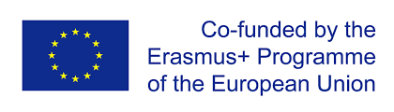
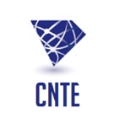
eTwinning Online Seminar Tunisia March2021

Venue : Microsoft Teams Date : 22-23 March 2021
Theme: Teaching with Media
Target Public: Secodary teachers (Age students: from 12 to 19)
Participating Countries: Tunisia-Albania-Jordan- France- BelgiumFL-BelgiumFR-Malta-Croatia-Denmark-Georgia- Lithuania- Netherlands-Romania-Hungary-Portugal-Italy- Moldova
Draft Program- Time CET
Day1 : Monday 22th March 2021ex
08:30-09:45 | Opening of Seminar | Wala Turki: DG CNTE
09:45-10:15 | Teaching with Media | Expert
10:15-11h:00 | Ice Breaking activities | NSO Tunisia
11:00-11:15 | Break
11:15-12:45 | Workshop (4or 5 parallel workshops/different rooms)
Workshop1 | Images Potential in eTwinning Activities to Unleash Students' Critical Thinking Skills | Tunisia
Workshop2 | Be smart with coding | Tunisia
Workshop3 | Project presentation on media education and misinformation | France
Workshop4 | Media Literacy and eTwinning | Croatia
Workshop5
12:45-13h | Plenary session
Day2: Tuesday 23th March 2021
08:30-8:45 | Plenary session
08:45-10:30 | -Sharing of new project Idea  - New projects registration
10:45-1100 | Break
11:00-12:30 | Project presentation
12:30-13 | Closing Seminar

